 | M a r S – T  ORDER FORM – version 13 |  |  | MarS a. s.  Okružní II 239; 569 43 Jevíčko  tel: +420 461 353 856, fax: +420 461 353 861  e-mail:mars@marsjev.cz  www.marsjev.com
Autorized dealer:  ________________________________________________________________________________________________________________________________ |  | purchaser:  Name, surname:  _________________________  Address:  City, postal code: __________________________  Country: __________________________  Tel./fax: __________________________  E-mail: __________________________ |  |  | The supporting harness, parachute container and the passenger´ s harnessMarS-T are delivered in one size that can be adjusted to different sizes.
Main canopy. HOP 330 Reserve canopy: WP-370, in white

Container embroidery: CONTAINER BACK PAD FABRIC: CORDURA 750 (NO. OF COLOUR 601-608)……………………
YES NO
CONTAINER TRIM TAPE COLOUR: CORDURA 750 (NO. OF COLOUR 31-43)…………………….
Appendix no.1
must be filled in ! HARNESS COLOUR ( WRITE NO. OF COLOUR ): _______________________________

CONTAINER COLOUR DESIGN: CORDURA 750 (NO. OF COLOUR 601-608):
CENTRAL FLAP COLOUR DESIGN
(PART NO. 3):
CENTRAL FLAP (PART NO. 3)  BACK PAD (PART NO. 4)  LEG PADS (PART NO. 10) |  |  | 1. __________________________  2. __________________________  4. __________________________  5. __________________________  6. __________________________  7. __________________________  8. __________________________  9. __________________________  10. _________________________  11. _________________________ |  |  | 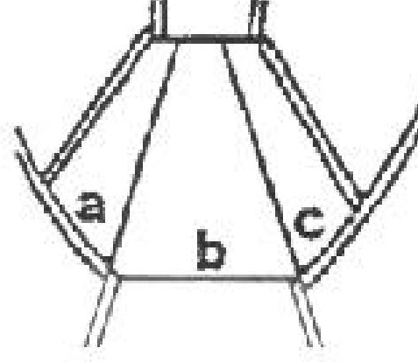  OPTION 1 | 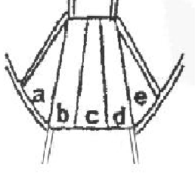  OPTION 2

a. ____________________________

b. ____________________________

c. ____________________________

d. ____________________________

e. ____________________________

DECORATION SEAM COLOUR (COLOUR NO. 31-43)
OPTION 1: 2 DECORATION SEAMS___
OPTION 2: 4 DECORATION SEAMS___

U-068 T CUTAWAY RIPCORD
Handle with a fabric coating, yellow handle

U-069 RESERVE PARACHUTE RIPCORD
Handle with a fabric coating, red handle

U-070 T DROGUE RIPCORD -PRIMARY: _____________
Textile handle, handle colour CORDURA (COLOUR NO. 601-608)

U-073 T DROGUE RELEASE/RIPCORD -SECONDARY: _____________
Plastic hose with a webbing (ČOLOUR NO. 31-43)

ADJUST CONTAINER FOR THE USE OF: m2 CYPRES VIGIL

STUDENT HARNESS:  PART NO. 1 – outer lining underlay  PART NO. 2 – outer lining  PART NO. 3 – inside lining | STUDENT HARNESS EMBROIDERY: YES NO  Appendix no. 1 must be filled in!  COLOUR CHOICES OF THE OUTER LINING, BACK PAD OUTER LINING UNDERLAY OF THE STUDENT HARNESS:  CORDURA 750 (Colour no. 601-608)  PART NO.1: _____________ PART NO.2: _____________  COLOUR CHOICES OF THE BACK PACK INSIDE LINING OF THE STUDENT HARNESS:  OPTION NO. 1:  CORDURA 750 (COLOUR NO. 601-608) PART NO.3: ___________  OPTION NO. 2:  UZARON (AVAILABLE COLOUR: BLACK)  PART NO.3: ___________  STUDENT HARNESS COLOUR: (WRITE no. OF COLOUR)_______  STUDENT HARNESS TRIM TAPE COLOUR  (No. of colour:31-43)-_______________  POCKET FOR KNIFE: NK-T01 NKM-02
RESERVE PARACHUTE PILOT CHUTE: PV-055, pilot chute colour depends on stock availability.

MAIN PARACHUTE RISERS: VK-44/500/TC-1 (LENGTH FROM THE DIVISION 500 mm),
colour is identical with the container/harness colour design

Basic version of the full container/harness MarS-T includes:
Container/harness, reserve parachute pilot chute, reserve parachute deployment bag, reserve parachute, reserve parachute steering loops, drogue, drogue suspension, main parachute deployment bag, main parachute, risers, main parachute steering loops, auxiliary equipment steering loops, cutaway ripcord, reserve parachute ripcord, drogue ripcord -primary, drogue ripcord - secondary, RSL-TANDEM release line, passenger (student) harness, logbook case, packing mat, portable bag + set of spare parts.

Basic version of the container/harness includes:
Container/harness, drogue suspension, cutaway ripcord, reserve parachute ripcord, drogue ripcord -primary, drogue ripcord – secondary.

SPECIAL REQUIESTS:
………………………………………………………………………………………………………………………………………………………………………………………………………………………………………………………………………………………………………………………………………………………………………………………………………………………………………………………………………………………………………………………………………………………………………………………………………………………………………………………………………………………………………………………………………………………………………………………………………………………………………………………………………………………………………………………………………………………………………………………………………………………………………………………………………………………………………………………………………………………………………………………………………………………

Date: ………………… Signature: ……………………….

