(Explementary notes on the last page*)  dealer:  CUSTOMER  Name:  Phone.:  E-mail:  Country: | BODY PROPORTIONS:  Male feMale  Height: (cm)  Weight : (kg)  Chest: (cm)  Waist: (cm)  Thigh: (cm) | 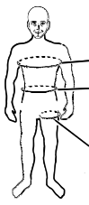 | PATTERN WHERE AND HOW TO MEASURE BODY PROPORTIONS:  chest  waist  thigh  Measure the height of the body barefoot.

In standard with magnetic cover flaps and with the stainless steel hardware.
Harness PS – 055 with rings – by chest and haunches.

The stainless steel hardware contains: the hardware of the complete harness incl. brake rings,parts at the risers to the main parachute
- 3 Ring Release System „MINI RING“ (diam. 33 mm).

SIZE OF CONTAINER:

Main canopy (size, type): Reserve canopy (size, type):

s  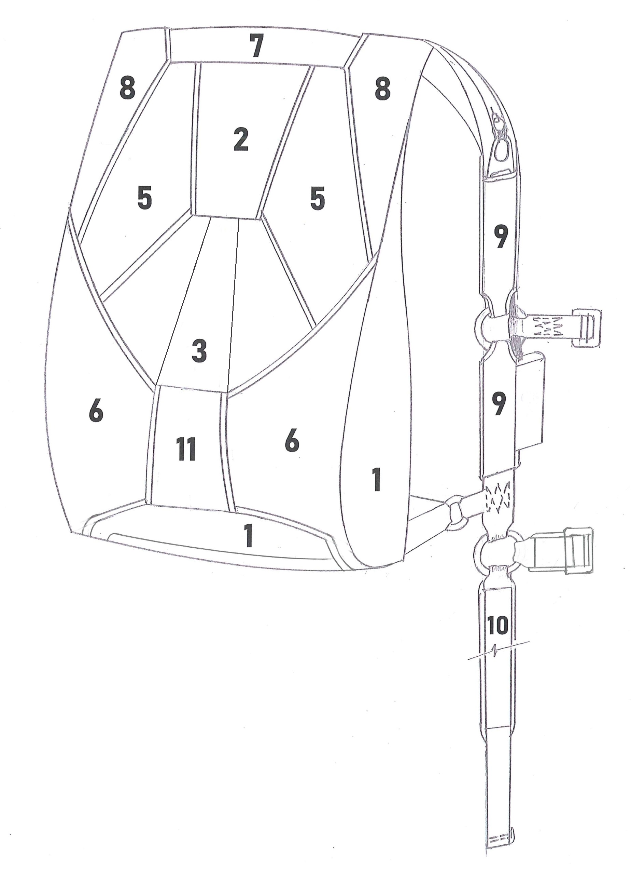  4 – Back Pad, 10 – Leg Pads  FABRIC OF CONTAINER: CORDURA  (COLORS No.) | COLORS:  Refer to diagram  1.  2.  4.  5.  6.  7.  8.  9.  10.  11.  COLOR OF HARNESS  (COLORS No.) | COLORS  CENTER FLAP STRIPES (NO. 3)  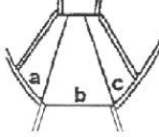  a.  b.  c.
   | 602 – Yellow |  | 608 – Dark Blue
   | 603 – Red |  | 609 – Green
   | 604 – Light Blue |  | 610 – White
   | 606 – Black |  | 611 – Light Grey
   | 607 – Dark Grey |  | 620 – Orange
   | 346 – Yellow |  | 369 – Grey
   | 344 – Red |  | 370 – Black
   | 342 – Light Blue |  | 341 – Dark Blue
COLORS OF TRIM:

(COLORS No.)
 | 10 – White |  | 36 – Dark Blue
 | 20 – Orange |  | 37 – Light Blue
 | 31 – Light Yellow |  | 39 – Green
 | 32 – Darkly Yellow |  | 40 – Green (khaki)
 | 33 – Red |  | 41 – Grey
 | 34 – Violet |  | 43 – Black

Note: Please contact your dealer for show card of colors.

MarS a. s. Okružní II 239; 569 43 Jevíčko, tel: +420 461 353 858, fax: +420 461 353 861, e-mail:mars@marsjev.cz, www.marsjev.com

Note: Adjustment for AAD m2 is in the standard.
EACH AAD DISPLAY IS IN TO BACK PAD.

CONTAINER READY FOR:

CYPRES VIGIL

RSL

3 RING RELEASE SYSTEM
Soft handle „U-079“, CORDURA FABRIC

(COLORS NO)
 | 602 – Yellow |  | 608 – Dark Blue
 | 603 – Red |  | 609 – Green
 | 604 – Light Blue |  | 610 – White
 | 606 – Black |  | 611 – Light Grey
 | 607 – Dark Grey |  | 620 – Orange

RESERVE HANDLE:
Soft handle „U-064“, CORDURA FABRIC

(COLORS NO)
 | 602 – Yellow |  | 608 – Dark Blue
 | 603 – Red |  | 609 – Green
 | 604 – Light Blue |  | 610 – White
 | 606 – Black |  | 611 – Light Grey
 | 607 – Dark Grey |  | 620 – Orange

RESERVE PILOT CHUTE:

PV – 028 PV – 055

Color of Pilot Chute:

MAIN PILOT CHUTE:

PV – 026 (Ø 900 mm) PV – 033 (Ø 800 mm)

Color of Pilot Chute:

MAIN PARACHUTE RISERS, 3 Ring Release System „MINI RING“ (diam. 33 mm), for Steering toggle pins, stainless steel:

Color:

VK-33/350/K-D RSL

VK-33/400/K-D

VK-33/500/K-D

The position drawing | Embroidery MACC  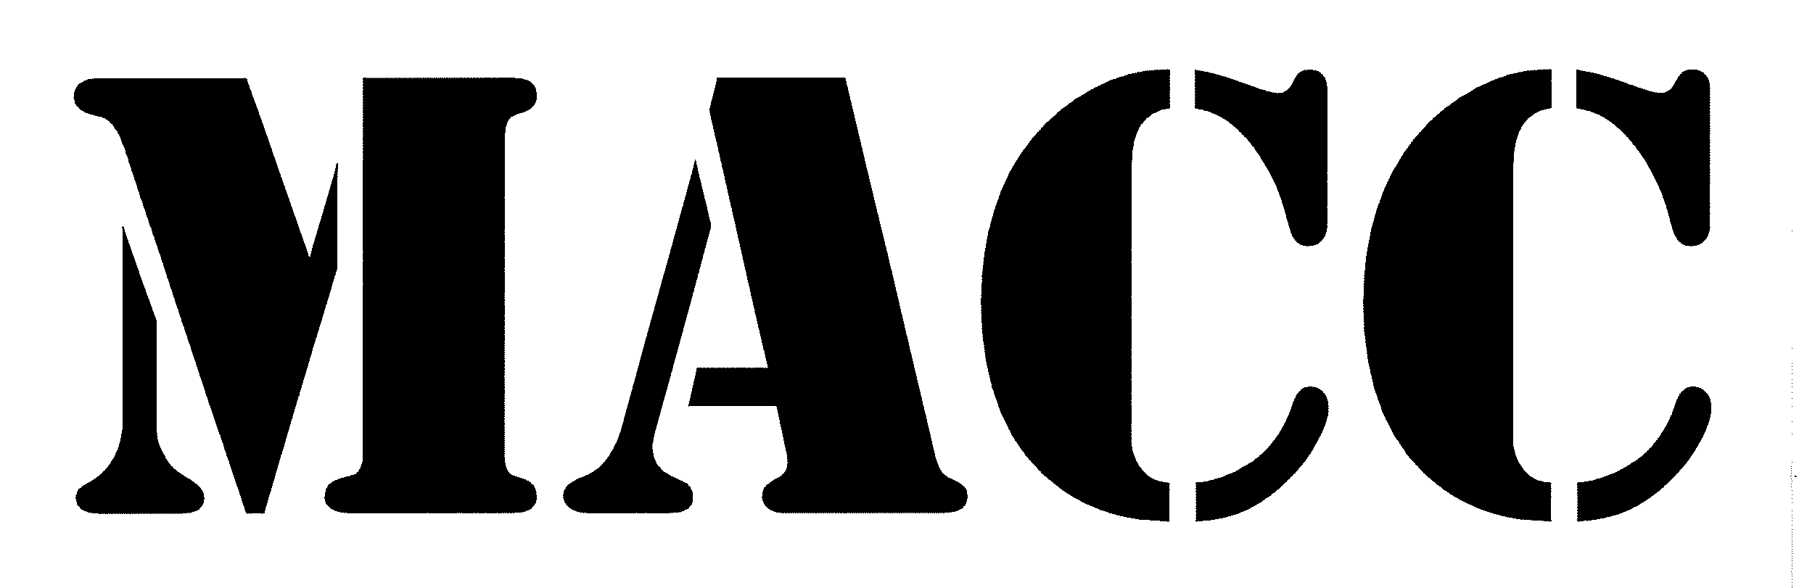  Embroidery MarS   | Embroidery of the logo „MarS“
  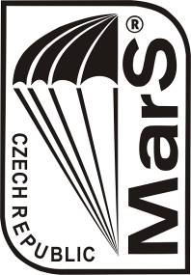

Right side of the container – Position no. 1
- Embroidery „MACC“ color of embroidery „MACC“ is always in dark grey color.
- Without embroidery

Left side of the container – Position no. 1
- Embroidery „MACC“ color of embroidery „MACC“ is always in dark grey color.
- Personal embroidery – at extra cost
- Without embroidery

Embroidery placed according to the container picture, Position no. 9 right
- Personal embroidery – at extra cost
- Without embroidery

Embroidery placed according to the container picture, Position no. 9 left
- Embroidery „MarS“ color of embroidery MarS
- Personal embroidery – at extra cost
- Without embroidery

RESERVE HANDLE „U-064“
- Embroidery „MarS“ color of embroidery
- Personal embroidery – at extra cost
- Without embroidery

3 RING RELEASE SYSTEM - HANDLE „U-079“
- Embroidery „MarS“ color of embroidery
- Personal embroidery – at extra cost
- Without embroidery

Note for your personal embroidery:

Please specify color (Text and Thread)

SPECIAL REQUEST:

Date Signature

*Explementary notes:

The document is locked and only color-coded fields are editable and need to be filled.
Marking boxes - double-click and select a color filling.

Boxes in the table - mark with a big "X".

Save the document to *.pdf and send to vala@marsjev.cz

